Unusual growth rates for Orbicella faveolata on a reef with high turbidity
Abstract
Introduction
Coral reefs develop under a set of environmental conditions and water properties that do not limit their growth and distribution at the local, regional or global level (Kleypas et al. 1999, Guan et al. 2015). This knowledge has been important to develop strategies for its conservation and management (McClanahan et al. 2002, Mora & Sale 2011). However, coral reefs continue to be threatened by climate change, ocean acidification, coral diseases and water pollution (Bruno et al. 2007, Hoegh-Guldberg et al. 2008, Knowlton & Jackson 2008, Hughes et al. 2011). These factors and human actions endanger the persistence of a valuable ecosystem that provides numerous benefits to mankind, i.e. food, medicine, wave protection, tourism (Bryant et al. 1998). The disappearance of coral reef ecosystems could mean enormous economic losses, mainly in countries that depend on their benefits (Cesar et al. 2003, Hoegh-Guldberg 2011).
In the Colombian Caribbean exists a coral reef which has been unnoticed for science, until recently (López-Victoria et al. 2015). Under the polluted and turbid waters of Cartagena Bay is located the Varadero reef. Unusually, the high live coral cover, diversity and big colonies of Orbicella faveolata characterize this coral reef. (López-Victoria et al. 2015). Currently, this reef is a source of economic and food resources for people living in nearby populations (Reference or pers. com.?). Although its origin is still unknown, the Varadero reef could be a remnant of the coral reefs that existed centuries ago in the Cartagena Bay (Martínez et al. 2010).
The Cartagena Bay became progressively an estuarine and sedimentary environment since it was connected to the Magdalena River through what is now known as the Canal del Dique. This canal was initiated by the Spaniards in 1650 and enlarged by the Colombian government up to the last century (Lemaitre 1982, Mogollón 2013). The Magdalena is the river with the highest sediment yield (contribution of sediments per area) in the Atlantic coast of South America with 560 ton km⁻² yr⁻¹, more than the Amazon, Orinoco and Paraná rivers together (Restrepo & Kjerfve 2000, Restrepo et al. 2006). Additionally, it is the river that discharges the most water volume in the Colombian Caribbean coast with 205.1 km³ yr⁻¹ (Restrepo et al. 2014). Coral reefs of the Cartagena region have been affected by the large turbidity plume of the Magdalena River in recent decades (Restrepo et al. 2016). The Varadero reef has withstood the progressive increase of water and sediment discharges from the Canal del Dique after a series of enlargements completed in 1930, 1952 and 1984, which dredged about 39 x 10⁶ m³, equivalent to 97% of all the material dredged in the history of the canal (Lemaitre 1982, Mogollón 2013). Records of the Canal del Dique in recent decades indicate an average water discharge of 397 m⁻³ s⁻¹ and sediment transport rate of 5.9 x 10⁶ ton yr⁻¹ into the Cartagena Bay (Restrepo et al. 2005, cited by Restrepo et al. 2017). This is in addition to the ENSO (El Niño-Southern Oscillation) events in the region, which causes a fluctuation of the water flow and sediment transportation (Restrepo et al. 2014, 2017).
The large size of the O. faveolata colonies are unusual in conditions such "unfavorable" as those of the Cartagena Bay. These large colonies may have the key to understanding the impact of man-made environmental changes in the history of Cartagena. Similar to tree growth rings, corals form growth bands, which help to identify the age of a colony, detect environmental anomalies, and estimate linear extension and calcification rates trough techniques used in sclerochronology (Knutson et al. 1972, Barnes & Lough 1996, Lough & Cooper 2011, Lough & Cantin 2014). Consequently, these corals can provide valuable information about the adaptations and responses to the turbid waters in the Cartagena Bay. In the present study we aim to understand the resilience of the Varadero reef through the growth recorded in the skeletons of the scleractinian coral O. faveolata.

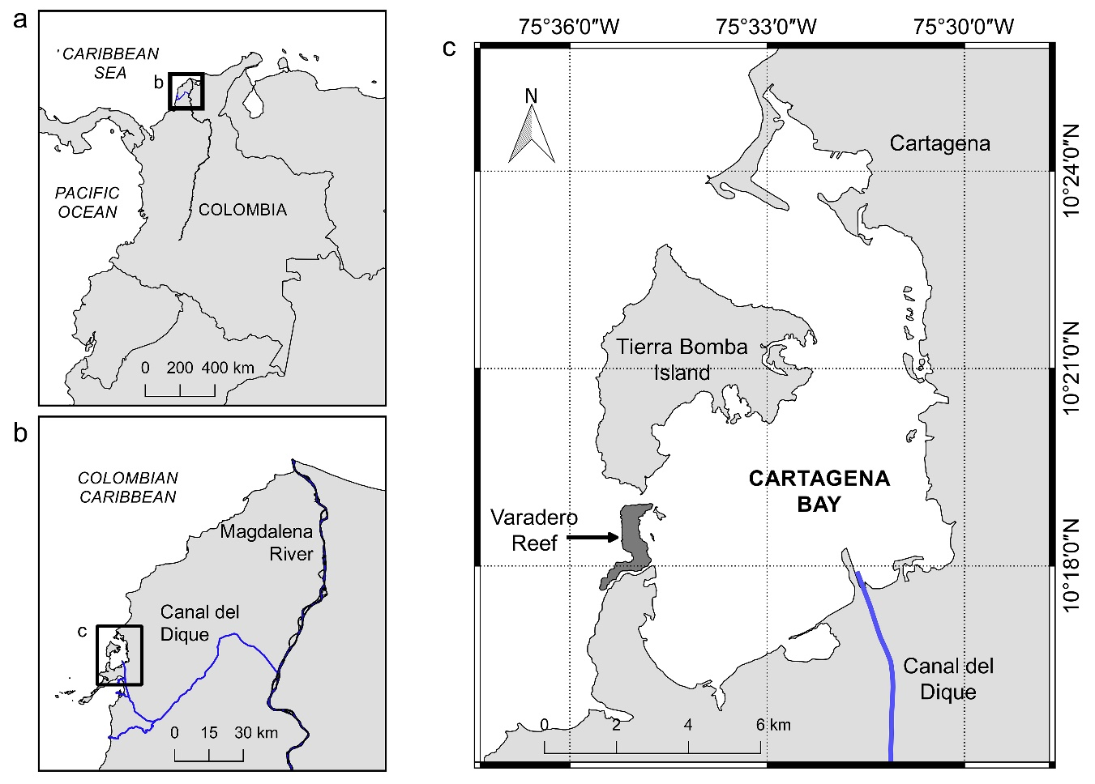
Fig.1. Map of the study site. Location and size of the Magdalena River (a), Canal del Dique (b), and the Varadero reef (c).
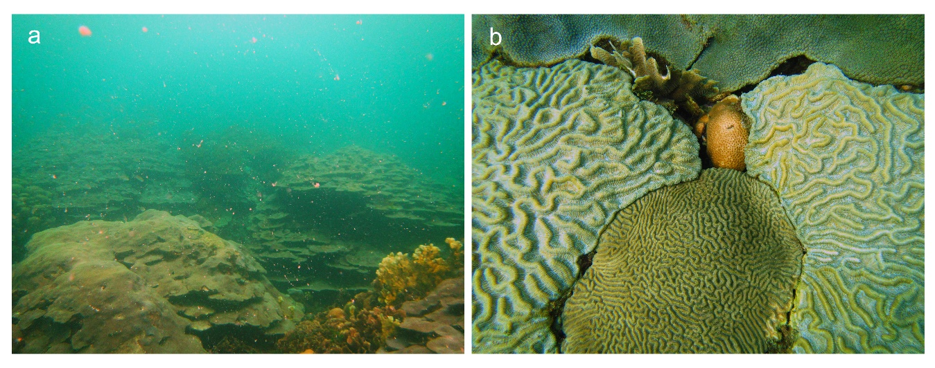
Material and methods
Study area
The Varadero reef is found 5.5 km adjacent to the mouth of the Canal del Dique, at the south channel of Cartagena Bay, Colombia (Fig. 1). The total extension of this reef is of about 1 km², with a live coral cover up to 80%, dominated by coral colonies of O. faveolata with >3 m diameter and different growth forms (López-Victoria et al. 2015) (Fig. 2). This well-developed coral reef is under the influence of the fluctuating run-off from the Canal del Dique, which discharges eutrophied inland waters with high sedimentation and organic matter. This produce a dense layer of turbidity on surface (1-2 m thick) with constant marine snow falling on the reef. Profiles of downward irradiance in the water column indicates a light attenuation of 80% at the reef bottom (6 m depth) (Iglesias-Prieto et al. unpublished data).
Sampling
Coral cores of 6 cm diameter and 50-80 cm long were collected with a pneumatic drill (as described by Marion 2006) along the growth axis from four massive colonies of O. faveolata (as round as possible) at 3-4 m depth. A polystyrene ball was inserted into the core hole and covered with epoxy putty to avoid bioerosion and sedimentation inside the colony. This also created a surface on which the coral tissue could spread. The cores were rinsed with fresh-water several times to remove sediment particles and then oven-dried for 24-48 h at 60°C.
Coral growth analysis
One core was sliced to 6 mm thick by using a saw with diamond-edge blade for cutting rock. The coral slab was radiographed under the following settings: ¿? kV and ¿? mA at 1 m of focal distance. An aragonite wedge obtained from the giant clam shell Tridacna gigas? was used as reference of density. The radiograph was digitized and analyzed following the method described by Carricart-Ganivet & Barnes (2007). Irradiation effects on radiograph were digitally corrected before the densitometric analysis (Duprey et al. 2012).
The other three coral cores were scanned trough a computerized tomography (CT) scanner: GE LightSpeed VCT 64-slice. Settings used were 5.6 cm slice thickness and 1.9 cm pixel spacing at 120 kV. This method was used in order to analyze coral growth from selected images at different planes (coronal and sagittal reconstructions) of unsliced coral cores. Unlike other CT-scan methods, here were used a step-wedge made from T. maxima to calibrate aragonite density from Hounsfield Units to gCaCO₃ cm⁻³ (Lizcano-Sandoval et al. in prep.). The step-wedge shows a gradient in coronal plane as observed in typical X-radiographs (Thunthy & Weinberg 1996). The DICOM files obtained were visualized on ImageJ 1.50b, and re-dimensioned from 512x512 to 2048x2048 pixels for a better appreciation of density bands.
The principles to analyze the coral cores were similar to those applied on the X-ray method. Annual density and linear extension rates were estimated. The calcification rates were calculated as the product of density and linear extension.
Luminescence analysis:
Historic record of environmental variables:
Results
Los especímenes de O. faveolata abarcaron un crecimiento entre 1950 y 2015. El promedio ± desviación estándar de densidad esquelética, tasas de extensión lineal y calcificación fueron 0.74 ± 0.07 gCaCO₃ cm⁻³, 1.07 ± 0.13 cm yr⁻¹, y 0.78 ± 0.09 gCaCO₃ cm⁻² yr⁻¹, respectivamente. En este periodo de tiempo se observó un antes y un después en el crecimiento de los corales, relacionado con el dragado del canal del Dique finalizado en 1984 (Fig. 3).
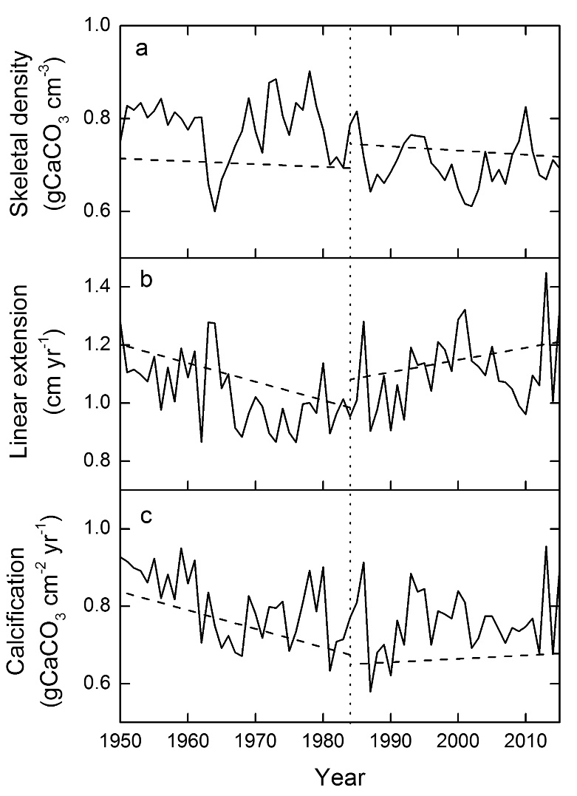
Fig. 3
El crecimiento de los especímenes de O. faveolata fue significativamente diferente después del dragado del Canal del Dique en 1984 en los aspectos de densidad esquelética y extensión lineal (Fig. 4).
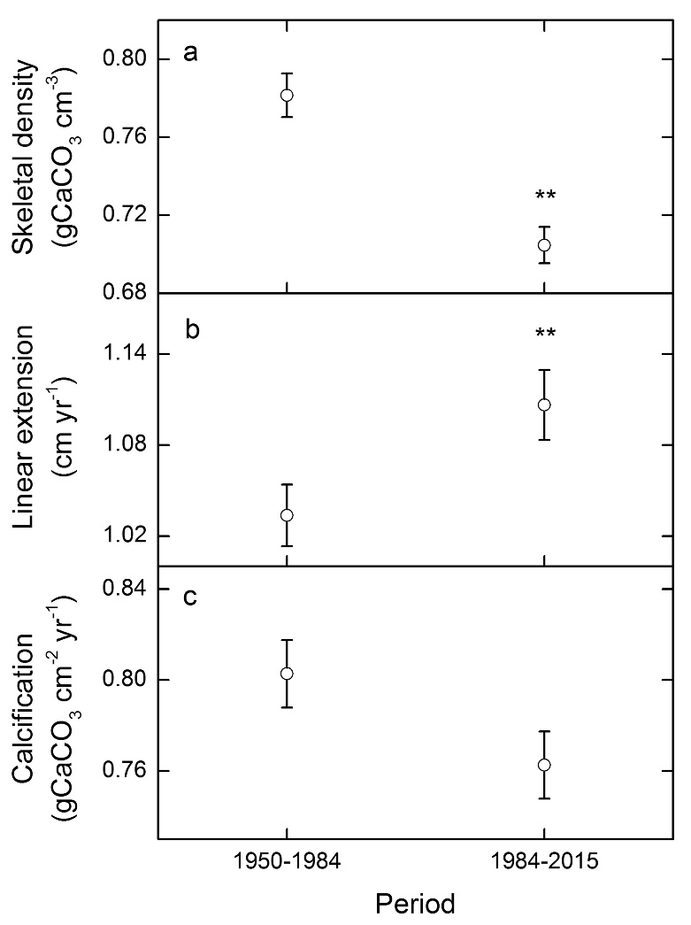
Fig. 4. Mean of skeletal density, linear extension and calcification rates of O. faveolata, before and after the Canal del Dique’s dredging in 1984. Vertical bars are standard error. **Significative differences (t-test, p < 0.05)

References
Barnes DJ, Lough JM (1996) Coral skeletons: Storage and recovery of environmental information. Glob Chang Biol 2:569–582
Bruno JF, Selig ER, Casey KS, Page CA, Willis BL, Harvell CD, Sweatman H, Melendy AM (2007) Thermal stress and coral cover as drivers of coral disease outbreaks. PLoS Biol 5:1220–1227
Bryant D, Burke L, McManus J, Spalding M (1998) Reefs at risk: A map-based indicator of threats to the world’s coral reefs. World Resources Institute, Washington D.C., USA
Carricart-Ganivet JP, Barnes DJ (2007) Densitometry from digitized images of X-radiographs: Methodology for measurement of coral skeletal density. J Exp Mar Bio Ecol 344:67–72
Cesar H, Burke L, Pet-Soede L (2003) The economics of worldwide coral reef degradation. Cesar Environmental Economics Consulting, The Netherlands
Duprey N, Boucher H, Jiménez C (2012) Digital correction of computed X-radiographs for coral densitometry. J Exp Mar Bio Ecol 438:84–92
Guan Y, Hohn S, Merico A (2015) Suitable environmental ranges for potential coral reef habitats in the tropical ocean. PLoS One 10:e0128831
Hoegh-Guldberg O (2011) Coral reef ecosystems and anthropogenic climate change. Reg Environ Chang 11:215–227
Hoegh-Guldberg O, Mumby PJ, Hooten AJ, Stenerck RS, Greenfield P, Gomez E, Harvell CD, Sale PF, Edwards AJ, Caldeira K, Knowlton N, Eakin CM, Iglesias-Prieto R, Muthiga N, Bradbury RH, Dubi RH, Hatziolos ME (2008) Coral reefs under rapid climate change and ocean acidification. Science (80- ) 318:1737–1742
Hughes TP, Baird AH, Bellwood DR, Card M, Connolly SR, Folke C, Grosberg R, Hoegh-Guldberg O, Jackson JBC, Kleypas J, Lough JM, Marshall P, Nyström M, Palumbi SR, Pandolfi JM, Rosen B, Roughgarden J (2011) Climate change, human impacts, and the resilience of coral reefs. Science (80- ) 301:929–933
Kleypas JA, McManus JW, Meñez LAB (1999) Environmental limits to coral reef development: Where do we draw the line? Am Zool 39:146–159
Knowlton N, Jackson JBC (2008) Shifting baselines, local impacts, and global change on coral reefs. PLoS Biol 6:215–220
Knutson DW, Buddemeier RW, Smith SV. (1972) Coral chronometers: Seasonal growth bands in reef corals. Science (80- ) 177:270–272
Lemaitre E (1982) Historia del Canal del Dique: Sus Peripecias y Vicisitudes. Constructora Sanz & Cia., Cartagena, Colombia
López-Victoria M, Rodríguez-Moreno M, Zapata FA (2015) A paradoxical reef from Varadero, Cartagena Bay, Colombia. Coral Reefs 34:231
Lough JM, Cantin NE (2014) Perspectives on massive coral growth rates in a changing ocean. Biol Bull 226:187–202
Lough JM, Cooper TF (2011) New insights from coral growth band studies in an era of rapid environmental change. Earth-Science Rev 108:170–184
Martínez JI, Yokoyama Y, Gomez A, Delgado A, Matsuzaki H, Rendon E (2010) Late Holocene marine terraces of the Cartagena region, southern Caribbean: The product of neotectonism or a former high stand in sea-level? J South Am Earth Sci 29:214–224
McClanahan T, Polunin N, Done T (2002) Ecological states and the resilience of coral reefs. Conserv Ecol 6:Art. 18
Mogollón JV. (2013) El Canal del Dique: Historia de un Desastre Ambiental. El Áncora Editores, Bogotá, Colombia
Mora C, Sale PF (2011) Ongoing global biodiversity loss and the need to move beyond protected areas: A review of the technical and practical shortcomings of protected areas on land and sea. Mar Ecol Prog Ser 434:251–266
Restrepo JC, Escobar J, Otero L, Franco D, Pierini J, Correa I (2017) Factors influencing the distribution and characteristics of surface sediment in the Bay of Cartagena, Colombia. J Coast Res 331:135–148
Restrepo JD, Kjerfve B (2000) Magdalena river: Interannual variability (1975-1995) and revised water discharge and sediment load estimates. J Hydrol 235:137–149
Restrepo JD, Kjerfve B, Hermelin M, Restrepo JC (2006) Factors controlling sediment yield in a major South American drainage basin: The Magdalena River, Colombia. J Hydrol 316:213–232
Restrepo JC, Ortíz JC, Pierini J, Schrottke K, Maza M, Otero L, Aguirre J (2014) Freshwater discharge into the Caribbean Sea from the rivers of Northwestern South America (Colombia): Magnitude, variability and recent changes. J Hydrol 509:266–281
Restrepo JD, Park E, Aquino S, Latrubesse EM (2016) Coral reefs chronically exposed to river sediment plumes in the southwestern Caribbean: Rosario Islands, Colombia. Sci Total Environ 553:316–329
Restrepo JD, Zapata P, Díaz JM, Garzón-Ferreira J, García C, Restrepo JC (2005) Aportes fluviales al mar Caribe y evaluación preliminar del impacto sobre los ecosistemas costeros. In: Restrepo JD (ed) Los Sedimentos del Río Magdalena: Reflejo de la Crisis Ambiental. Fondo Editorial Universidad EAFIT, Medellín, Colombia, p 187–215
Thunthy KH, Weinberg R (1996) Effects of tomographic motion, slice thickness, and object thickness on film density. Oral Surg Oral Med Oral Pathol Oral Radiol Endod 81:368–73

